**7.shoppingapp**

**Step-1: Created a shoppingapp react project**

**>npx create-react-app shoppingapp**

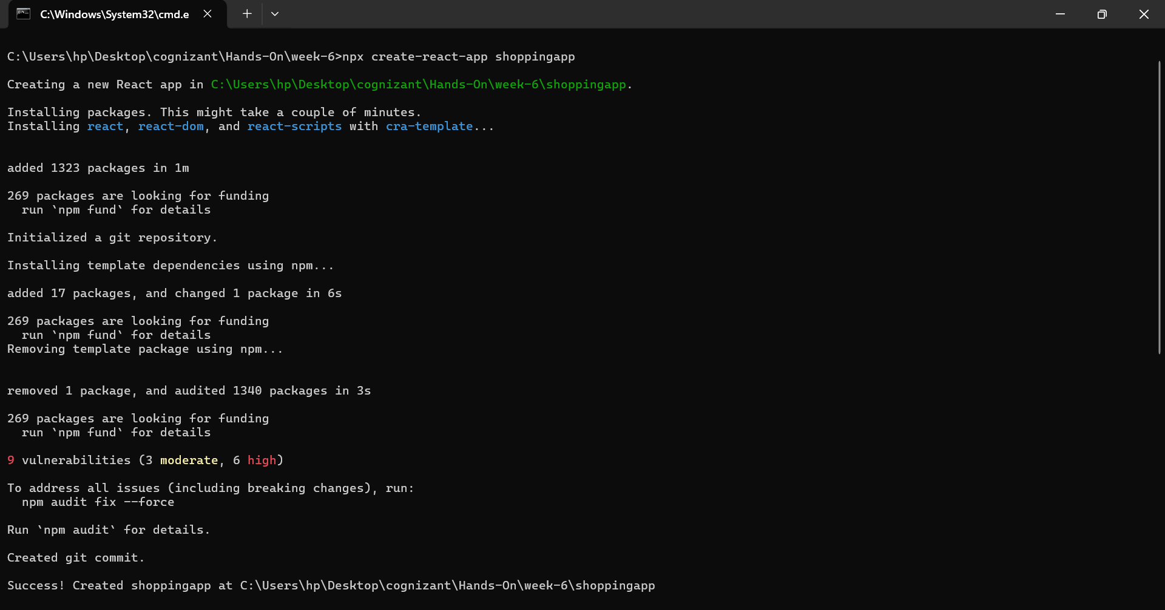

**Step-2:Ceated two class components in src/components/**

**OnlineShopping.js**

import React from 'react';

import {Cart} from './cart';

export class OnlineShopping extends React.Component {

  render() {

    const cartItems = [

      { itemname: "Laptop", price: 80000 },

      { itemname: "TV", price: 120000 },

      { itemname: "WashingMachine", price: 50000 },

      { itemname: "Mobile", price: 30000 },

      { itemname: "Fridge", price: 70000 }

    ];

    return (

      <div>

        <h2 style={{color: 'green', textAlign:"center" }}>Items Ordered</h2>

        <Cart items={cartItems} />

      </div>

    );

  }

}

**Cart.js**

import React from "react";

export class Cart extends React.Component {

  render() {

    return (

     <div style={{alignItems:"center"}}>

      <table border="1" style={{ color:"green", margin: "auto" , textAlign: "center" }}>

        <thead>

          <tr>

            <th>Name</th>

            <th>Price</th>

          </tr>

        </thead>

        <tbody>

          {this.props.items.map((item, index) => {

            return (

              <tr key={index}>

                <td>{item.itemname}</td>

                <td>{item.price}</td>

              </tr>

            );

          })}

        </tbody>

      </table>

    </div>

    );

  }

}

**App.js**

import {OnlineShopping} from "./components/OnlineShopping";

function App() {

  return (

    <div className="App">

      <OnlineShopping/>

    </div>

  );

}

export default App;

**Step-3;**

**OUTPUT:**

